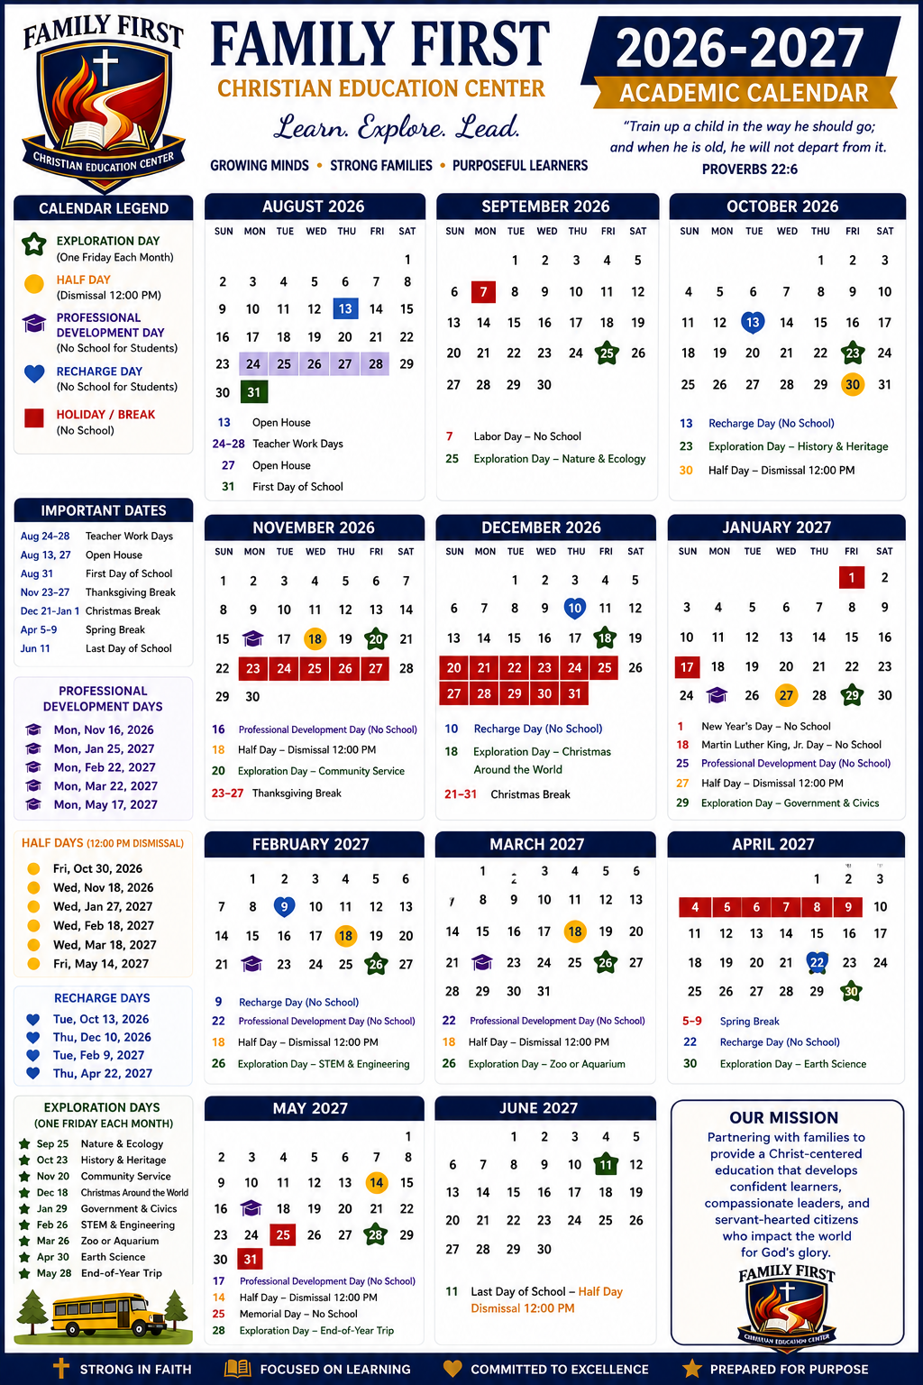
🌿 Wellness & Recharge Days
At Family First Christian Education Center, we believe that healthy minds, strong character, and joyful hearts are just as important as academic success.
Throughout the school year, we intentionally schedule Wellness & Recharge Days to give students an opportunity to slow down, reset, and return to learning refreshed. These planned breaks help prevent burnout, reduce stress, and support healthy emotional, spiritual, and academic growth.
During these days, students are encouraged to:
- Spend quality time with family.
- Enjoy outdoor recreation and fresh air.
- Read for pleasure.
- Explore personal interests and hobbies.
- Serve their community.
- Rest and recharge.
We believe that learning is most effective when students have opportunities to balance hard work with healthy rest. By intentionally building these days into our school calendar, we are teaching students an important life lesson: rest is not a reward for finishing—it is a healthy part of living well.
"Come to me, all who labor and are heavy laden, and I will give you rest." — Matthew 11:28

